**Apache Axis -2**

Apache Axis2™ is a Web Services / SOAP / WSDL engine, the successor to the widely used Apache Axis SOAP stack. It is a Tool and API.

Download Link:

<http://a.mbbsindia.com/axis/axis2/java/core/1.7.2/axis2-1.7.2-bin.zip>

Download and Extract.

Configure Server : Apache Tomcat in eclipse.

-=-=-=-=-=-=-=-=-=-=-=-=-=-=-=-=-=-=-=-=-=-=-=-=-=-=-=-=-=-=-=-=-=-=-=-=-=-=-=-=-=-=-=-=-=-=-

1. Download the latest Axis2 runtime from the above link and extract it.
2. Now we point Eclipse WTP to downloaded Axis2 Runtime. Open **Window -> Preferences -> Web Services -> Axis2 Emitter**   
   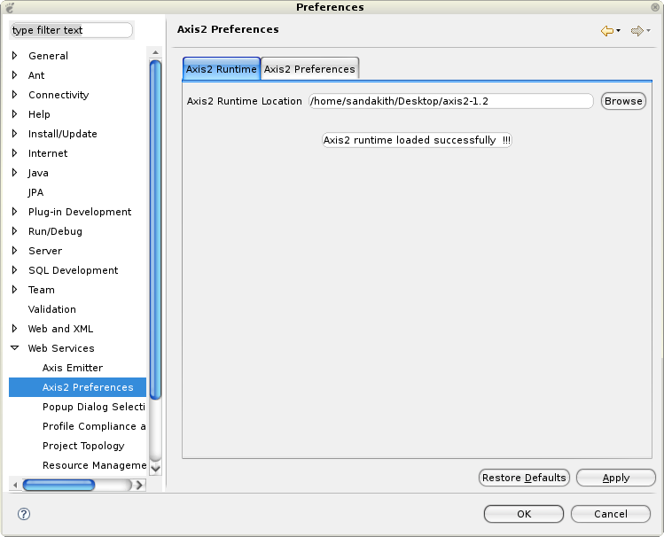

Select the Axis2 Runtime tab and point to the correct Axis2 runtime location. Alternatively at the Axis2 Preference tab, you can set the default setting that will come up on the Web Services Creation wizards. For the moment we will accept the default settings.

1. Click OK.
2. Next we need to create a project with the support of Axis2 features. Open **File -> New -> Other... -> Web -> Dynamic Web Project**   
   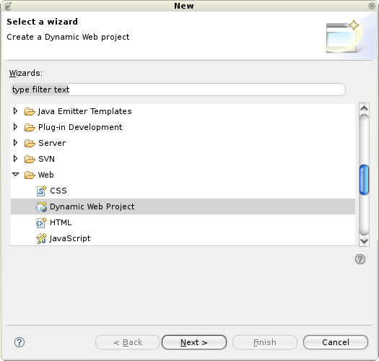

Click next

1. Select the name **Axis2WSTest** as the Dynamic Web project name (you can specify any name you prefer), and select the configured Tomcat runtime as the target runtime.   
   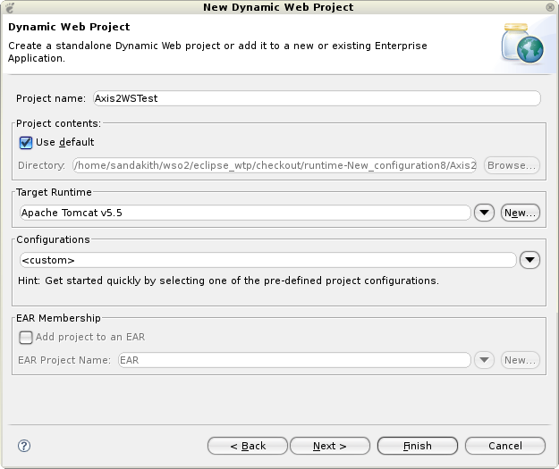

Click next.

1. Select the Axis2 Web service facet   
   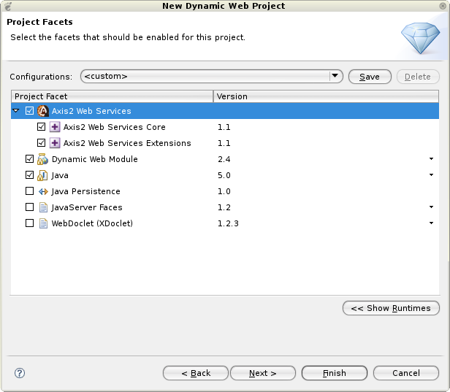

Click Finish.

1. This will create a dynamic Web project in the workbench   
   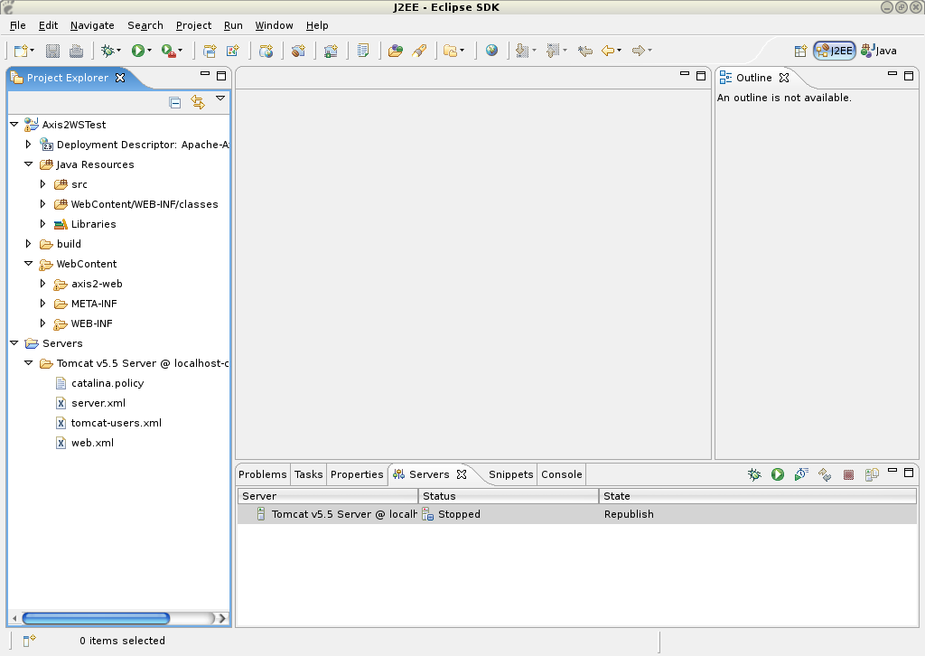
2. Import the [wtp/Converter.java](http://www.eclipse.org/webtools/community/tutorials/BottomUpAxis2WebService/code/Converter.java) class into Axis2WSTest/src (be sure to preserve the package).   
   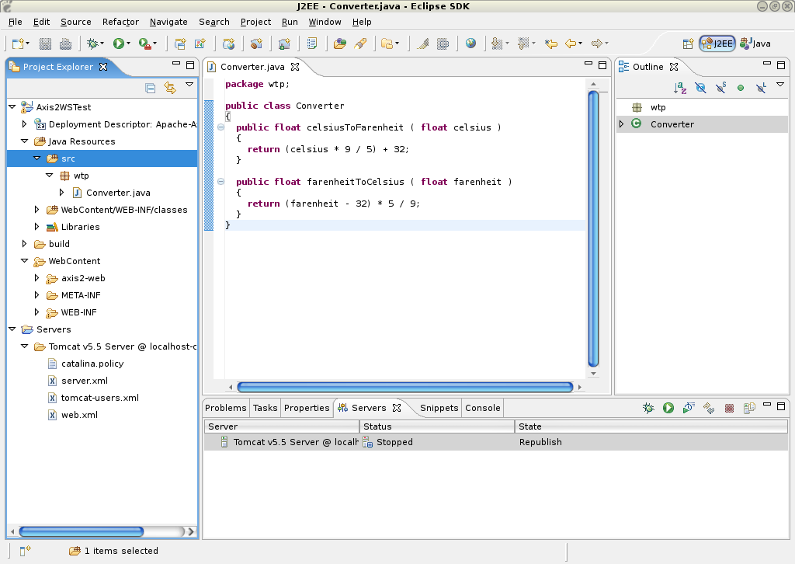

Build the Project, if its not auto build.

1. Select Converter.java, open File -> New -> Other... -> Web Services -> Web Service   
   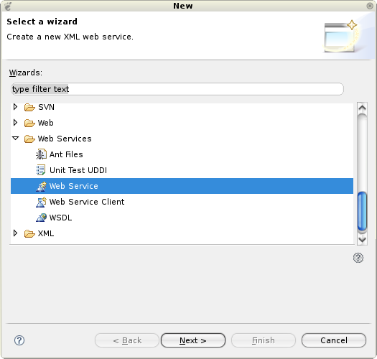

Click next.

1. The Web service wizard would be brought up with Web service type set to **Bottom up Java bean Web Service** with the service implementation automatically filled in. Move the service scale to**Start service**.   
   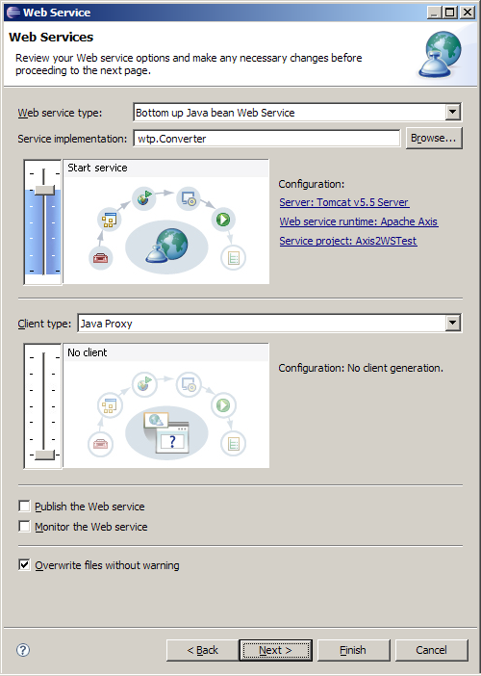
2. Click on the **Web Service runtime** link to select the Axis2 runtime.   
   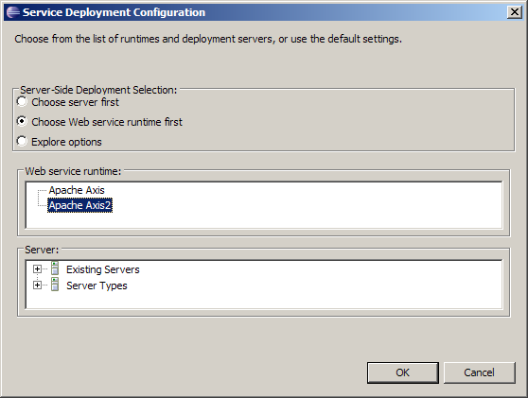

Click OK.

1. Ensure that the correct server and service project are selected as displayed below.   
   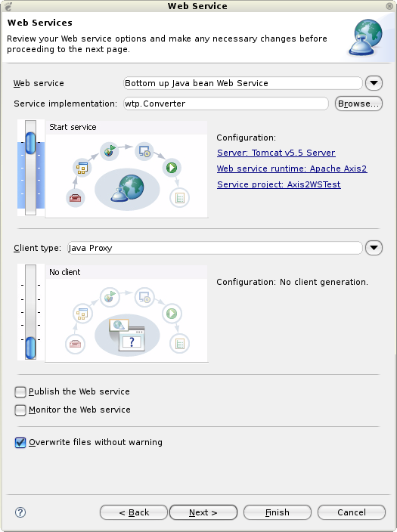

Click next.

1. This page is the service.xml selection page. if you have a custom services.xml, you can include that by clicking the **Browse** button. For the moment, just leave it at the default.   
   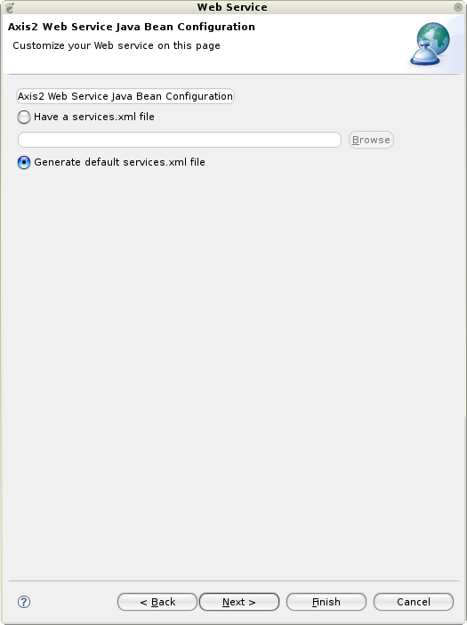

Click next.

1. This page is the Start Server page. It will be displayed if the server has not been started. Click on the **Start Server** button. This will start the server runtime.   
   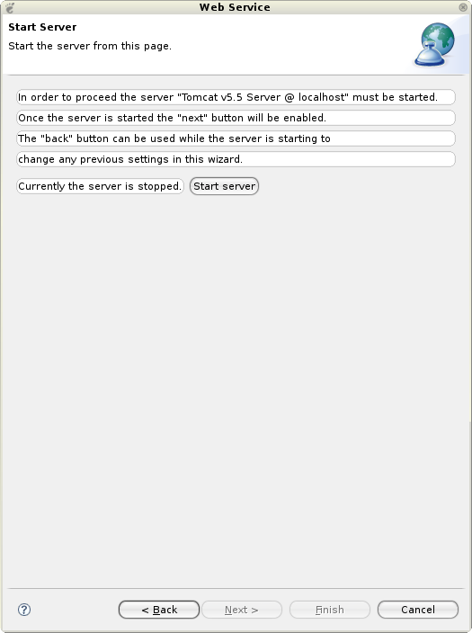

Click next.

1. This page is the Web services publication page, accept the defaults.   
   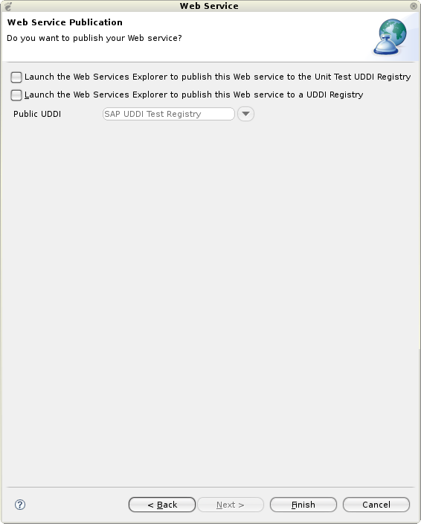

Click Finish.

1. Now, select the **Axis2WSTest** dynamic Web project, right-click and select Run -> Run As -> Run on Server to bring up the Axis2 servlet.   
   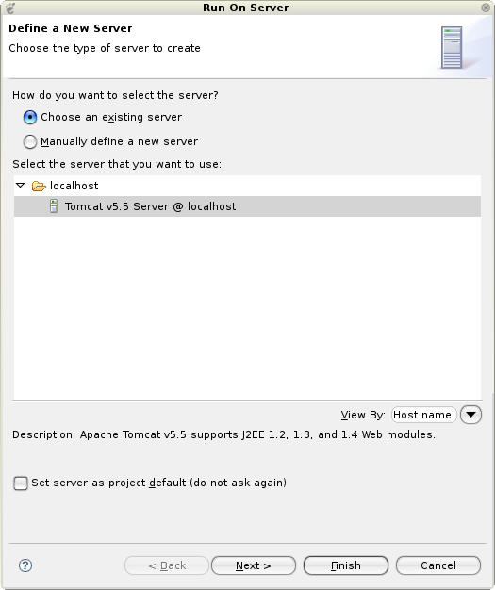

Click Next.

1. Make sure you have the **Axis2WSTest** dynamic Web project on the right-hand side under the Configured project.   
   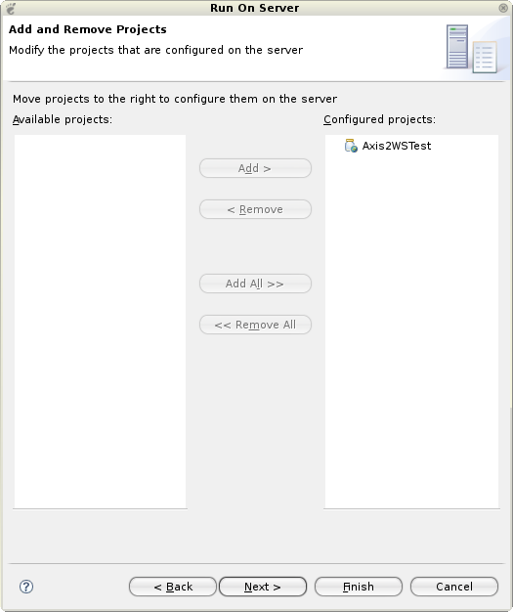

Click Finish.

1. This will deploy the Axis2 server webapp on the configured servlet container and will display the Axis2 home page. Note that the servlet container will start up according to the Server configuration files on your workspace.   
   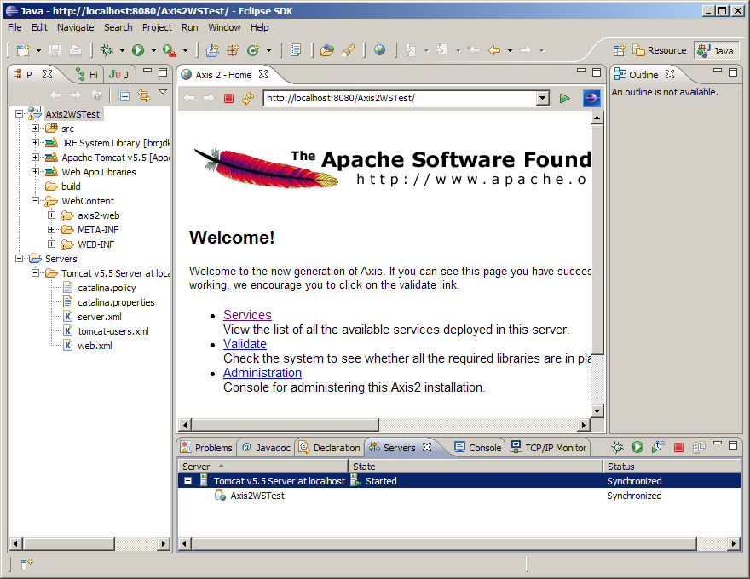
2. Click on the **Services** link to view the available services. The newly created converter Web service will be shown there.   
   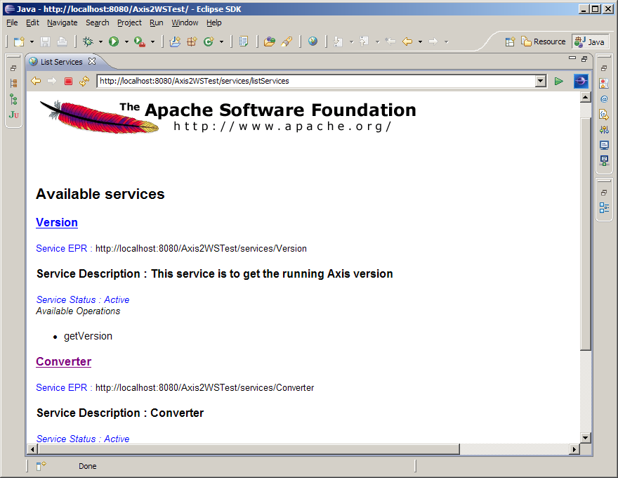
3. Click on the **Converter Service** link to display the ?wsdl URL of the newly created Web service. Copy the URL.   
   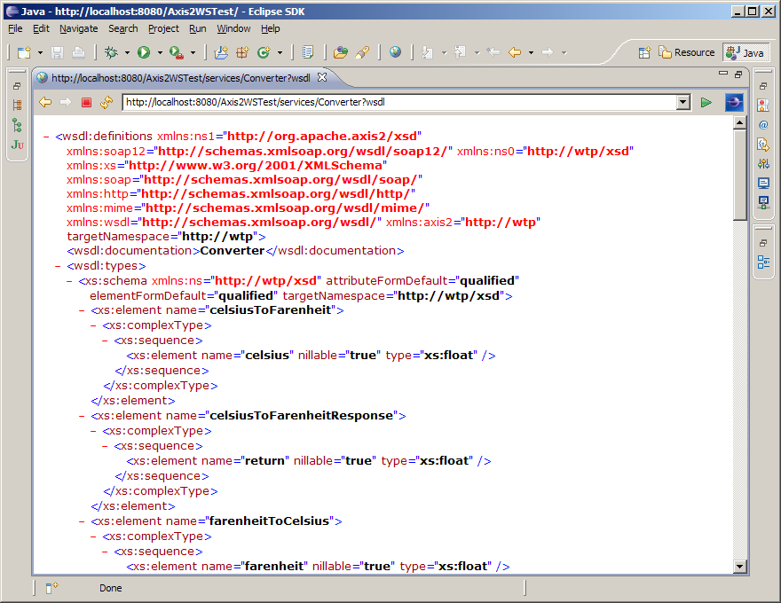
4. Now we'll generate the client for the newly created service by referring the ?wsdl generated by the Axis2 Server. Open File -> New -> Other... -> Web Services -> Web ServiceClient   
   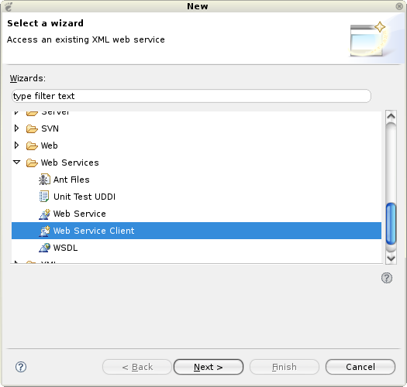
5. Paste the URL that was copied earlier into the service definition field.   
   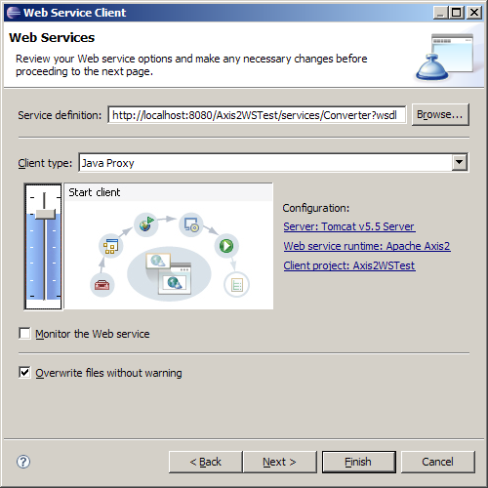
6. Click on the **Client project** hyperlink and enter **Axis2WSTestClient** as the name of the client project. Click OK.   
   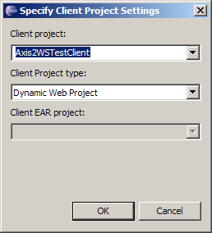
7. Back on the Web Services Client wizard, make sure the Web service runtime is set to Axis2 and the server is set correctly. Click Next.   
   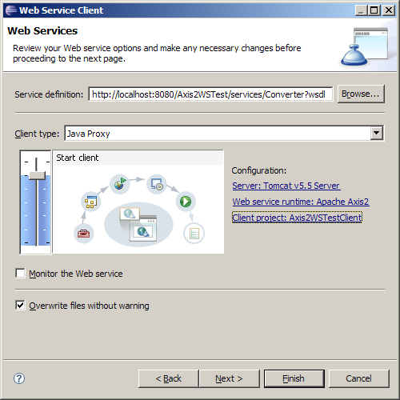
8. Next page is the Client Configuration Page. Accept the defaults and click Finish.   
   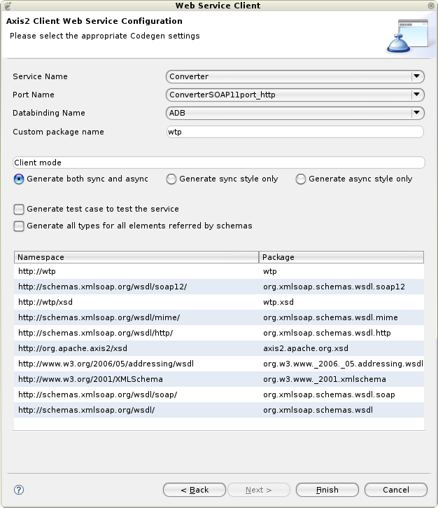

Once stubs are generated Dentine Client class/Bind class .

Task: Try for client class for above process.

//steps : create object for stub, create object for input message and call operation pass input message object, that returns output message object. Use a method get_return() on output message object.